Oyster Task Force Meeting
Tuesday, August 16, 2022, 1:00PM
East Bank Regional Library
4747 W Napoleon Ave
Metairie, LA 70001

I. Pledge of Allegiance
II. Roll call and introduction of guests
Voting Members Present:
Shane Bagala
Jakov Jurisic
Mitch Jurisich
Brad Robin
Brandt Lafrance
Sam Slavich
Peter Vujnovich
Willie Daisy

Voting Members Absent:
Tracy Collins
Dan Coulon
Al Sunseri
Matthew Slavich

Non-Voting Members Present:
Carolina Bourque
Justin Gremillion
Bryan Marie
Sarah in for Karl Morgan
Harry Vorhoff

Non-Voting Members Absent:
Brian Lezina

III. Brad Robin motioned to approve the June 7, 2022 meeting minutes, 2nd by Peter Vujnovich. Motion carries.

Brad Robin motioned to approve the August 16, 2022 meeting agenda, 2nd by Jakov Jurisic. Motion carries.
IV. Treasury Report- Oyster Development Account
Remaining Fund Balance- $544,605
Remaining Budget Balance- $67,808

Brad Robin motioned to accept the treasury report as presented, 2nd by Peter Vujnovich. Motion carries.

V. Committee Reports
- Public-Private Oyster Seed Grounds Committee- no report
- Enforcement Report-

REGION 6
Terrebonne:
1-Harevest oysters w/o harvesters license.
1-Take commercial fish w/o gear license oyster scraper.
1-Harvest Oyster illegal hours.
Seized 9 sacks oysters
Lafourche:
5–take oysters from unapproved area(polluted)
1–fail to display proper numbers on vessel
2-violate sanitation code (log book)
1-violate sanitation code (tarp)
Seized 15 sacks oysters

REGION 8
St. Bernard Parish:
Violate sanitation code (refrigeration-white tags):
Sanitation code (log book)-1
Fail to fill out oyster tags correctly-1
Take commercial fish without gear license (oyster scrapper): 3
Total sacks seized: 357
Plaquemines Parish:
Sanitation code (refrigeration-lot ID)-1
Sanitation code (waste bucket)- 2
Sanitation code (tarp)- 1
Sanitation code (false deck)-1
Sanitation code (log book)-1
Unlawfully take oyster from private lease: 3
Fail have written permission: 3
Take oysters from unleased state water bottoms: 5
Total sacks seized: 67
- Legislative Report- no report
- Legal report- no report
- Research Report- no report
- Coastal Restoration- no report
- Marketing Report-
Sandy Garcia provided feedback on the OTF oyster industry commercial; plans to have a day on the water with BMF; edits complete for the .30 second spot and .60 second spot, will air on the Saints game opener; commercials will run through the end of October
Jakov Jurisic stated the possibility of extending the programming once this one comes out; will we have any idea on how effective these spots were? Sandy Garcia stated that there is monthly reporting that shows attribution back to the website; Jakov Jurisic requested that WWL report back on the findings of the commercial
Anna trying to revise and update the website content to keep it up and fresh, want to get this going before the oyster commercial airs
Jakov Jurisic stated that the SPMB hasn’t met since didn’t get the opportunity to talk to the board but by the next OTF meeting will try and get information on a date and the agenda; seafood cook-off with LT Governor
JZL suggested the OTF get a slogan or tag line to go along with their campaign; would suggest “Eat Oysters Save our Coast”
Jakov Jurisic stated that he would like to look into getting an official license plate for the LA oyster industry-“ Love LA”; Anna Koehl stated that she will look into the license plate and costs and will report back at the next meeting
- Health Report
Justin Gremillion stated that a portion of area 15 that was closed due to an oil spill, precautionary closure of ten square miles, do not know if there are any oyster that have been affected yet. Did pull some shrimp samples to test hydrocarbon levels and those have been tested and will get results this week, after these results come back this will help guide the next steps with oysters and testing and if everything comes back good will reopen the area
Justin Gremillion addressed item C. under new business at this time, the item was to request that LDH take samples in Bay Coquette and Sandy Point for a possible opening. Justin Gremillion stated that the last two years they have been opening the area up without having enough samples, but they have gone in and tried to collect enough but by the time we get to the end of sampling we get written up, due to storms and have to shut the area down until samples are retrieved; will continue to try; will immediately start taking samples September 1 we will need 5 sets taken from September- October, the only time the area is open from September/ October, may be able to deviate from the normal opening to get the crop that is there depending on the samples; task force asked if LDH could consider a later opening if good samples are yielded; stated that there is a possibility to open, will look into this and keep the task force updated on what is going on in the area; testing for fecal coliform in the samples
Map showing August 17 at Jefferson Parish Health Unit on the East Bank
Jakov Jurisic asked about the previously discussed ISSC issues with green tags regarding time and temperature and bringing this issue to the executive board meeting/ ISSC; need paperwork so the OTF can reach out for executive board or ISSC conference, executive board is meeting in March 2023 in Baton Rouge; would like to change rules on green tag, eliminated 24 hours now only have 18 and 12 hours to refrigeration; will have something by the next meeting, plan on hosting a committee meeting for further discussion
Steve Pollock asked if it would be possible to report the number of confirmed and reported oyster related illnesses in the state for the health committee meeting; last death from vibrio was in 2018; interested in coliform illness that have been reported and confirmed and vulnificus reports
- Aquaculture Report
Mitch Jurisich stated that Brandi Shelley resigned as chair of the aquaculture committee, appointed Steve Pollock as the new committee chairman
- Joint Task Force Working Group- no report
VI. New Business
- Carolina Bourque provided a presentation on the oyster stock assessment results and the 2022/23 oyster season recommendations
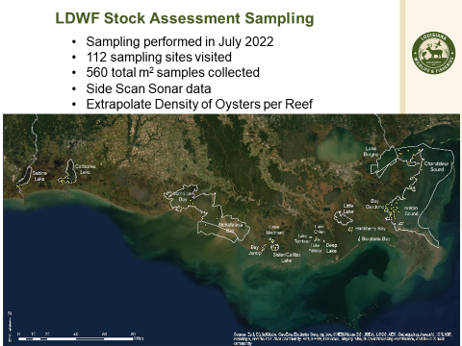
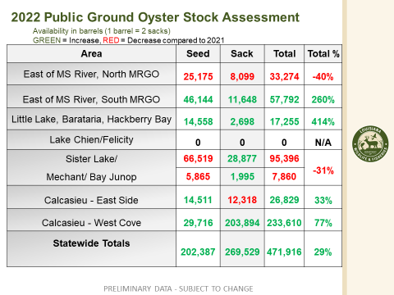
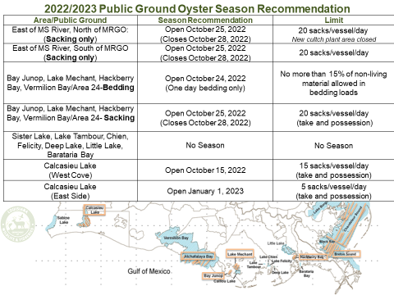
Mitch Jurisich stated that one good thing about the recommendation is that we are opening everything at once and keeping the boats spread out and everyone can work their own area, the issue with the 4 days is that you are only talking about oysters you found at sample sites and with a 4 day season, 20 sack limit these boats will not have a chance to look around they will have to go out and pretty much try and get their 80 sacks for the season without having the chance to go out and possibly find oysters that LDWF may have missed; would like to do a quota instead of a short season, when the state opens shrimp season they do not limit the catch, 20 sack limit with fuel and distance this is going to be very difficult, can this be modified?, think there will be a need for more days, do not want to leave resource out there, can someone be a scout for a few days and take enforcement and come back with a report, just a suggestion to get a better idea of what is out there, would like for LDWF to look into extending the season
Carolina Bourque stated that always have a quota for every area for example last year in Sister Lake the quota was not reached so they were able to do two extra openings; if quota is not reached can do extra openings, hopes that Day on the Bay can find new areas
Jakov Jurisic motioned that the Oyster Task Force wait to make an official recommendation on the Oyster Season until the industry is able to host a few Days on the Bay, need multiple days to scout areas and then come back an provide a recommendation to LDWF, 2nd by Peter Vujnovich. Motion did not pass, motion was withdrawn.
Brad Robin agrees, looking at price of vessel, fuel, license, 20 sacks for a day, some areas take three hours to get out to the area and then if there is bad weather, 4 days is not feasible, in order to get the resources up need to let the fishermen get out there and have the opportunity to look, need to look into areas, no one is going to scrape and take everything off the resource, time to check and move around, thinks that two days on the bay will give the opportunity and then to come back and revisit this
Mitch Jurisich stated that the harvest effort will not be there because it’s not worth it for the profit
Willie Daisy stated that he is very disappointed in the presentation in the Sister lake area
Carolina Bourque stated that she would need the results from the Day on the Bay and a recommendation back before the September 1 LDWF Commission meeting, Day on the Bay would have to go all next week to produce results in time, season is usually set for the first Wednesday after Labor Day; asked if the task force would it help to change to a 7 day and 25 sacks/ day statewide season and will still use quota, move the dates and could open btw October 25- October 31st
Tony Tesvich stated that moving from 25 sacks to 20 sacks is an insult would like to look at 30 sacks/ day, 2 day limit should be allowed knows there is an issue with enforcement the industry has great coolers, should trust the industry with a 2-day limit- there is a cooler and harvest log
John Tesvich in the legislation you have the first Wednesday after Labor Day is the opening of oyster season, the LDWF Commission has to meet to keep it closed otherwise it would automatically open, regarding the limits and quotas and why don’t you set a quota and then set a limit and let it stay open until the limit is met, what happened in Sister Lake last year, the industry doesn’t know what to do with that and it’s moving people out of the business, suggested discussing quota instead of setting an arbitrary sack limit
Sam Slavich stated that the economic reality of harvesting oysters for sale for profit, in this situation the numbers do not meet the economic reality of the people trying to harvest
Brad Robin stated that didn’t LDWF just bed in the Drum Bay area a large portion of ground and isn’t the old shell plant opening? What is opening and what is closing? Carolina Bourque stated that the area just bedded would stay closed and everything else would be open including the Lake Fortuna shell plant area
John Tesvich stated that he recommends the areas open on a certain day for sacking with a 50-sack limit with LDWF doing daily surveys to see what is taken out of each area and make a decision on closure after seeing real data and what the production actually is
Jakov Jurisic stated that opening some areas would give the task force time to come up with recommendation
Jakov Jurisic withdrew his motion on the floor, Peter Vujnovich approved of the withdraw as the 2nd
John Tesvich stated that this method is not working, appeal to LDWF commissioners that it’s time to change something up, think we need more cultivation, recommend making that recommendation regardless of if it’s way off from LDWF’s recommendation
Brad Robin motioned to make an oyster season recommendation as follows, Vermillion Bay- 1-day bedding to open on September 7th; 2022 1-day bedding for Hackberry Bay, Lake Mechant, and Bay Junop to open October 9th; Statewide opening for sacking on October 10th, 50 sacks per day, with a 2-day possession limit, closing April 1, 2023; with the exception of Calcasieu Lake (West Cove) which would open on October 15th and Calcasieu Lake (East Side) which would open on January 1st, 2023 West Cove 15 sacks/vessel/day and East Side no more than 5 sacks/ vessel/ day, possession for entire Calcasieu Lake no more than 15 sacks/vessel/day, 2nd by Peter Vujnovich. Motion carries.
- Crystal Johnson provided the task force with a presentation
SAFE Oyster Project
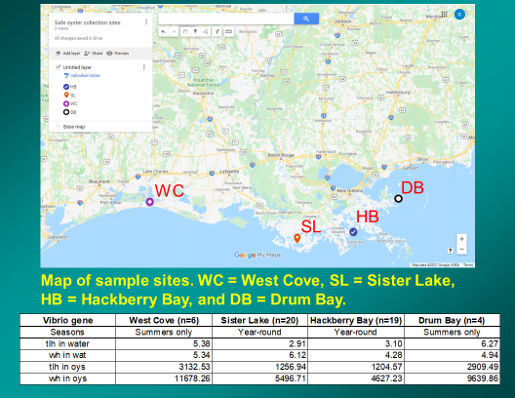
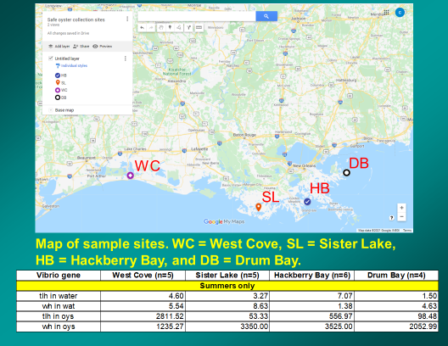
John Tesvich stated that the temperature is directly coorelated to the vibrio levels but so is salinity, when salinity is below 10PPT vibrio is almost 0, in sea water salt water is 30PPT vibrio is almost 0 as well
- Mitch Jurisich led discussion on AOC oyster harvesting regulations
Mitch Jurisich stated that he received several phone calls about a show that just aired on YouTube or Bayou Wild TV that depicted AOC oyster harvesting. There were some concerns with how the oysters were harvested. During the whole show and time the oysters were being harvested the oysters are never shown under a tarp and no refrigeration means on the boat. It was brought to my attention that we need to look into the AOC harvesting regulations. People need to be educated and informed about the regulations and that they have to follow the same regulations as a traditional oyster harvester
Steve Pollock stated that he spoke to the gentlemen that was a part of that TV special and was told that the tarp was removed at the front of the boat to have better lighting for camera shooting and the oysters were for personal consumption that is why there were no tags
- Jakov Jurisich motioned to fund fuel for two ‘Days on the Bay’, 2nd by Brad Robin. Motion carries. *To participate the boat would have to leave the dock with a full tank of fuel, when you come back you fill back up*
Areas looking at are east of the river and north and south of MRGO, Tony Tesvich agreed to do it, one or two biologists have to be present, proposed dates- August 23-24,
VII. Public Comment
Darrah Bach announced that CRCL is building oyster reefs out of recycled oyster shells, they are hosting public days in Montegut, LA and putting out 150 tons in Bayou Point-au-Chien, all bagged oysters, also just visited reef built last year in Adam’s Bay it’s doing really well
Pointe-au-Chien Community Reef #2 Deployment

Friday, September 23

Montegut, LA

10:00 AM - 3:00 PM

Pointe-au-Chien Community Reef #2 Deployment

Friday, September 30

Montegut, LA

10:00 AM - 3:00 PM

The Coalition to Restore Coastal Louisiana (CRCL) is excited to have you join us in Montegut, LA! Launched in June 2014, CRCL’s Oyster Shell Recycling Program recycles shell from participating New Orleans-based restaurants and uses that shell to restore oyster reefs and shoreline habitat across Coastal Louisiana. In 2019, CRCL, in partnership with the Pointe-au-Chien Indian Tribe, completed the construction of the Pointe-au-Chien Community Reef to protect the integrity of a historic mound site from further erosion. We are excited to be deploying a second reef, which will be protecting a mound complex with several sacred mound sites from wave action and erosion. Parking and registration will occur at the Pointe-au-Chien Indian Tribal Community Center. Volunteers will load bagged oyster shells onto trailers, trucks, and boats at the Pointe-au-Chien Indian Tribal Community Center to facilitate on-the-water deployment by Pointe-au-Chien community members and staff. Volunteers will be taking a boat ride (~10mins) from the Community Center to the project site to deploy the bags of oyster shells.
VIII. The next Oyster Task Force meeting set for Tuesday, September 20, 2022 for 1:00pm at the New Orleans Lakefront Airport, Committee meetings set prior to the OTF meeting: Health Committee meeting for 10am, Aquaculture Committee meeting 11am
IX. Jakov Jurisic motioned to adjourn the meeting, 2nd by Peter Vujnovich. Motion carries.

